Cash basis = recognize money when it moves (what hit your card).
Accrual basis = recognize an expense when it is consumed, regardless of who paid or when.

Accounts and People are different axes. The payer should NOT be added as an account.

 | I consumed | Friend P consumed
I paid | my budget +, no debt | P owes me
P paid | I owe P, my budget + | P's own expense (often out of scope)

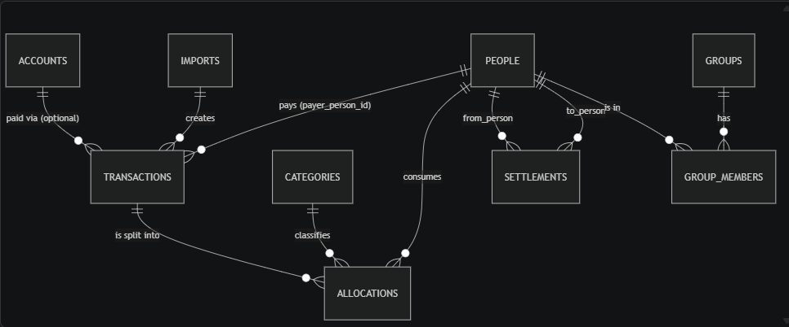

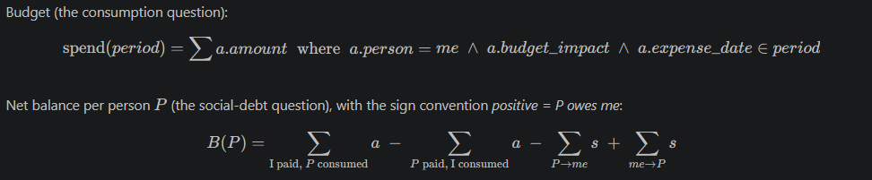

TRANSACTION LIFECYCLE:
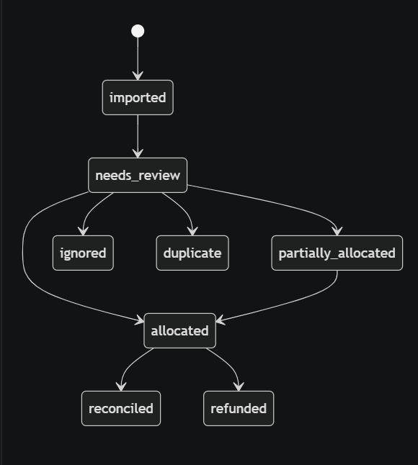

To find out duplicates:
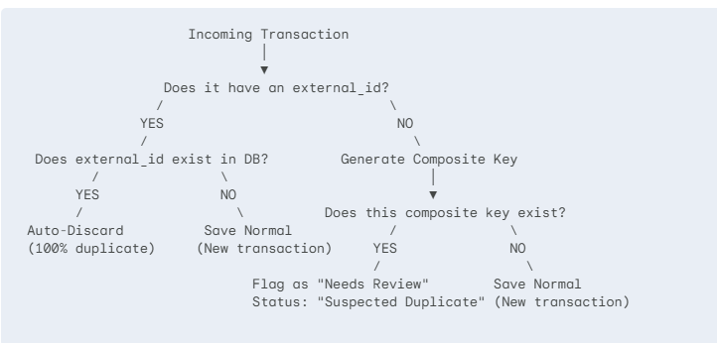

INVARIANT (True at all times):
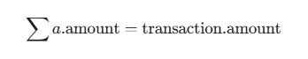



SCENARIO SPEC AND EXPECTED OUTPUT:
